**COMMUNICATION RADAR SYSTEM**

**BY**

**IDOLOR KESTER ODAFE**

**EE/17/291**

**ELETRICAL/ELECTRONIC ENGINEERING DEPARTMENT MADONNA UNIVERSITY AKPUGO CAMPUS**

**IN PARTIAL FULFILMENT OF THE REQUIREMENTS FOR THE AWARD OF BACHELOR IN ENGINEERING (B.ENG) IN ELETRICAL ELECTRONIC ENGINEERING SPEECIALIZING IN ELECTRONICS AND COMMUNICATION SYSTEM**

**MAY, 2022.**

**CERTIFICATION**

This Project ‘**Communication Radar System’’ by IDOLOR KESTER ODAFE** (EE/17/291) under the supervision of Engr. Dr. M. Alor has been read and approved as meeting the requirements and fulfillment for the award of a B.Sc. degree in the Department of Electrical Electronic Engineering, Madonna University Nigeria, Akpugo Campus.

----------------------------- ---------------

**Idolor kester odafe Date**

(**Student)**

------------------------------ ---------------

**Engr. Dr. M. Alor**  Date

**(Project Supervisor)**

.

-------------------------- ---------------

**Engr. Dr. A. A. Omeche** Date

**(Head of Department)**

**DEDICATION**

This report is dedicated to the Almighty God for his ideas, love, mercy, who in his preservative mercies and loving kindness kept me alive and also gave me the strength and ability to make this project a success. To my wonderful and loving family, my joy knows no bounds for their unconditional love, care, moral, and financial support. May Almighty God guide and protect them all, Amen.

**ACKNOWLEDGEMENT**

My utmost appreciation goes to Almighty God for seeing me through this project work. I also thank my parents for their endless and innumerable support and contributions toward my academic pursuit. My project supervisor Engr. Dr. M. Alor. For his intense contribution towards my work, and my Head of Department Engr. Dr. A. A. Omeche, without them it would have been impossible.

Also, I want to acknowledge the entire staff of Electrical Electronic Engineering Department.

**ABSTRACT**

Radar systems have received attention extensively in recent years for remote detection and monitoring for healthcare and security applications. Monitoring the primary vital signs is essential to evaluate people's physical and occasionally mental health, to assess potential symptoms of diseases and to follow up on patients’ recovery. Human activity sensing plays a vital role in intelligent home and health monitoring applications. Data observed from human activities is appropriated for improving our lifestyle. In this work, recent implementations of both contact and remote radar systems are presented. The article also discusses required antennas’ specifications for mentioned applications.

**TABLE OF CONTENTS**

Title ii

Certification iii

Dedication VI

Acknowledgement v

Abstract VI

Table of content vii

**CHAPTER ONE: INTRODUCTION**

* Background of the study 1
* Statement of problem 2
* Aim and objectives 2

**CHAPTER TWO: LITERATURE REVIEW**

2.1 Theory of Work 3

2.2 Other Related Works 5

**CHAPTER THREE: METHODOLOGY**

3.1 Materials 13

3.2 Principle of Operation 17

3.3 Result 17

**CHAPTER FOUR: CONCLUSION** 18

**REFERENCES**

**LIST OF FIGURES**

**CHAPTER ONE**

**INTRODUCTION**

* **Background of Study**

RADAR (acronym for RAdio Detection And Ranging) is an object-detection system that uses radio waves to determine the range, altitude, direction, or speed of objects. It can be used to detect aircraft, ships, spacecraft, guided missiles, motor vehicles, weather formations, and terrain. The radar dish or antenna transmits pulses of radio waves or microwaves that bounce off any object in their path. The object returns a tiny part of the wave's energy to a dish or antenna that is usually located at the same site as the transmitter. Radar was secretly developed by several nations before and during World War II. The term RADAR itself, not the actual development, was coined in 1940 by the United States Navy as an acronym for Radio Detection and Ranging.

The term radar has since entered English and other languages as the common noun radar, losing all capitalization. The modern uses of radar are highly diverse, including air traffic control, radar astronomy, air-defense systems, antimissile systems; marine radars to locate landmarks and other ships; aircraft anti-collision systems; ocean surveillance systems, outer space surveillance and rendezvous systems; meteorological precipitation monitoring; altimetry and flight control systems; guided missile target locating systems; and ground-penetrating radar for geological observations.

Radio detection and ranging is nothing but the radar, in the past few decades, the radar has become very famous in several major fields like research, aircraft, and commerce. Initially, the radar was developed for the military purposes and later it was used in wide range of applications.

The British and United States military use the radar for locating the ships and airplanes and to know about them. Now radar is a vital tool to predict the weather and to analysis the weather. Along with all these benefits, there are some disadvantages of radar too like the timings of radar because it takes two seconds to lock it.

**Statement of the problem**

It is observed that the human brain cannot be seen with our bare eyes, thus, the human mental state is helpless. When our vehicle gets stolen, recovering it is a great challenge, when two aerodromes are in motion in an opposite direction it is very difficult for both pilot to detect, hence they could collide. But with radar system, the human brain can be viewed, thus, issues like brain tumor is easy to identify, with radar system our stolen vehicles can be recovered through tracker. Also, the radar system in aerodromes makes it possible for pilot to detect upcoming planes with their speed, therefore, there would not be any collision of aerodromes.

**Aim and objectives**

The essence of this project is to do an extensive research into the working principal of a communication radar system, highlighting its application, recent technological advancement, limitation and possible improvement to the system and to construct an Arduino-based prototype of a radar system that detects object easily and process the signal into a digital form that can be visualized on a supported display device.

**CHAPTER TWO**

**LITERATURE REVIEW**

**HISTORY**

Before diving into any technicalities involved in the working principal and operations of a Radar System, it is very important to highlight on the major historical timelines, events and personalities involved in the development and improvement that has brought the Radar system infrastructure to where and what it is today.

**First Experiment**

As early as 1886, German physicist [Heinrich Hertz](https://en.wikipedia.org/wiki/Heinrich_Hertz) showed that radio waves could be reflected from solid objects. In 1895, [Alexander Popov](https://en.wikipedia.org/wiki/Alexander_Stepanovich_Popov), a physics instructor at the [Imperial Russian Navy](https://en.wikipedia.org/wiki/Imperial_Russian_Navy) school in [Kronstadt](https://en.wikipedia.org/wiki/Kronstadt), developed an apparatus using a [coherer](https://en.wikipedia.org/wiki/Coherer) tube for detecting distant lightning strikes. The next year, he added a [spark-gap transmitter](https://en.wikipedia.org/wiki/Spark-gap_transmitter). In 1897, while testing this equipment for communicating between two ships in the [Baltic Sea](https://en.wikipedia.org/wiki/Baltic_Sea), he took note of an [interference beat](https://en.wikipedia.org/wiki/Interference_beat) caused by the passage of a third vessel. In his report, Popov wrote that this phenomenon might be used for detecting objects, but he did nothing more with this observation.[[6]](https://en.wikipedia.org/wiki/Radar#cite_note-6)

The German inventor [Christian Hülsmeyer](https://en.wikipedia.org/wiki/Christian_H%C3%BClsmeyer) was the first to use radio waves to detect "the presence of distant metallic objects". In 1904, he demonstrated the feasibility of detecting a ship in dense fog, but not its distance from the transmitter.[[7]](https://en.wikipedia.org/wiki/Radar#cite_note-RadarWorld-7) He obtained a patent, for his detection device in April 1904 and later a patent for a related amendment for estimating the distance to the ship. He also obtained a British patent on 23 September 1904[[10]](https://en.wikipedia.org/wiki/Radar#cite_note-10) for a full radar system, that he called a ***telemobiloscope***. It operated on a 50 cm wavelength and the pulsed radar signal was created via a spark-gap. His system already used the classic antenna setup of horn antenna with parabolic reflector and was presented to German military officials in practical tests in [Cologne](https://en.wikipedia.org/wiki/Cologne) and [Rotterdam](https://en.wikipedia.org/wiki/Rotterdam) harbor but was rejected.[[11]](https://en.wikipedia.org/wiki/Radar#cite_note-11)

In 1915, [Robert Watson-Watt](https://en.wikipedia.org/wiki/Robert_Watson-Watt) used radio technology to provide advance warning to airmen[[12]](https://en.wikipedia.org/wiki/Radar#cite_note-12) and during the 1920s went on to lead the U.K. research establishment to make many advances using radio techniques, including the probing of the [ionosphere](https://en.wikipedia.org/wiki/Ionosphere) and the detection of [lightning](https://en.wikipedia.org/wiki/Lightning) at long distances. Through his lightning experiments, Watson-Watt became an expert on the use of [radio direction finding](https://en.wikipedia.org/wiki/Radio_direction_finding) before turning his inquiry to [shortwave](https://en.wikipedia.org/wiki/Shortwave) transmission. Requiring a suitable receiver for such studies, he told the "new boy" [Arnold Frederic Wilkins](https://en.wikipedia.org/wiki/Arnold_Frederic_Wilkins) to conduct an extensive review of available shortwave units. Wilkins would select a [General Post Office](https://en.wikipedia.org/wiki/General_Post_Office) model after noting its manual's description of a "fading" effect (the common term for interference at the time) when aircraft flew overhead.

Across the Atlantic in 1922, after placing a transmitter and receiver on opposite sides of the [Potomac River](https://en.wikipedia.org/wiki/Potomac_River), U.S. Navy researchers [A. Hoyt Taylor](https://en.wikipedia.org/wiki/A._Hoyt_Taylor) and [Leo C. Young](https://en.wikipedia.org/wiki/Leo_C._Young) discovered that ships passing through the beam path caused the received signal to fade in and out. Taylor submitted a report, suggesting that this phenomenon might be used to detect the presence of ships in low visibility, but the Navy did not immediately continue the work. Eight years later, [Lawrence A. Hyland](https://en.wikipedia.org/wiki/Lawrence_A._Hyland) at the [Naval Research Laboratory](https://en.wikipedia.org/wiki/Naval_Research_Laboratory) (NRL) observed similar fading effects from passing aircraft; this revelation led to a patent application[[13]](https://en.wikipedia.org/wiki/Radar#cite_note-13) as well as a proposal for further intensive research on radio-echo signals from moving targets to take place at NRL, where Taylor and Young were based at the time.[[14]](https://en.wikipedia.org/wiki/Radar#cite_note-14)

Similarly, in the UK, L. S. Alder took out a secret provisional patent for naval radar in 1928. [[15]](https://en.wikipedia.org/wiki/Radar#cite_note-15) [W.A.S. Butement](https://en.wikipedia.org/wiki/W._A._S._Butement) and P. E. Pollard developed a breadboard test unit, operating at 50 cm (600 MHz) and using pulsed modulation which gave successful laboratory results. In January 1931, a write up on the apparatus was entered in the ***Inventions Book*** maintained by the Royal Engineers. This is the first official record in Great Britain of the technology that was used in coastal defense and was incorporated into [Chain Home](https://en.wikipedia.org/wiki/Chain_Home) as [Chain Home (low)](https://en.wikipedia.org/wiki/Chain_Home_Low).

**Just before World War II**

[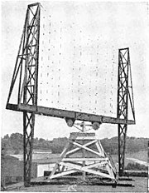](https://en.wikipedia.org/wiki/File:Early_radar_antenna_-_US_Naval_Research_Laboratory_Anacostia.jpg)

Experimental radar antenna, US [Naval Research Laboratory](https://en.wikipedia.org/wiki/Naval_Research_Laboratory), Anacostia, D. C., from the late 1930s (photo taken in 1945).

Before the [Second World War](https://en.wikipedia.org/wiki/Second_World_War), researchers in the United Kingdom, [France](https://en.wikipedia.org/wiki/French_Third_Republic), [Germany](https://en.wikipedia.org/wiki/Nazi_Germany), [Italy](https://en.wikipedia.org/wiki/Kingdom_of_Italy), [Japan](https://en.wikipedia.org/wiki/Japanese_Empire), the Netherlands, the [Soviet Union](https://en.wikipedia.org/wiki/Soviet_Union), and the United States, independently and in great secrecy, developed technologies that led to the modern version of radar. Australia, Canada, New Zealand, and South Africa followed prewar Great Britain's radar development, and [Hungary](https://en.wikipedia.org/wiki/Regency_of_Hungary) generated its radar technology during the war.

In France in 1934, following systematic studies on the [split-anode magnetron](https://en.wikipedia.org/wiki/Cavity_Magnetron#Split-anode_magnetron), the research branch of the [Compagnie générale de la télégraphie sans fil](https://en.wikipedia.org/wiki/Compagnie_g%C3%A9n%C3%A9rale_de_la_t%C3%A9l%C3%A9graphie_sans_fil) (CSF) headed by Maurice Ponte with Henri Gutton, Sylvain Berline and M. Hugon, began developing an obstacle-locating radio apparatus, aspects of which were installed on the ocean liner [*Normandie*](https://en.wikipedia.org/wiki/SS_Normandie) in 1935.

During the same period, Soviet military engineer [P.K. Oshchepkov](https://en.wikipedia.org/wiki/Pavel_K._Oshchepkov), in collaboration with the [Leningrad Electrotechnical Institute](https://en.wikipedia.org/wiki/Saint_Petersburg_State_Electrotechnical_University), produced an experimental apparatus, RAPID, capable of detecting an aircraft within 3 km of a receiver. The Soviets produced their first mass production radars RUS-1 and RUS-2 Redut in 1939 but further development was slowed following the arrest of Oshchepkov and his subsequent [gulag](https://en.wikipedia.org/wiki/Gulag) sentence. In total, only 607 Redut stations were produced during the war. The first Russian airborne radar, [Gneiss-2](https://en.wikipedia.org/wiki/Gneiss-2), entered into service in June 1943 on [Pe-2](https://en.wikipedia.org/wiki/Petlyakov_Pe-2) dive bombers. More than 230 Gneiss-2 stations were produced by the end of 1944. The French and Soviet systems, however, featured continuous-wave operation that did not provide the full performance ultimately synonymous with modern radar systems.

Full radar evolved as a pulsed system, and the first such elementary apparatus was demonstrated in December 1934 by the American [Robert M. Page](https://en.wikipedia.org/wiki/Robert_Morris_Page), working at the [Naval Research Laboratory](https://en.wikipedia.org/wiki/Naval_Research_Laboratory). The following year, the [United States Army](https://en.wikipedia.org/wiki/United_States_Army) successfully tested a primitive surface-to-surface radar to aim [coastal battery](https://en.wikipedia.org/wiki/Coastal_artillery) [searchlights](https://en.wikipedia.org/wiki/Searchlight) at night. This design was followed by a pulsed system demonstrated in May 1935 by [Rudolf Kühnhold](https://en.wikipedia.org/wiki/Rudolf_K%C3%BChnhold) and the firm [GEMA](https://en.wikipedia.org/w/index.php?title=Gesellschaft_f%C3%BCr_elektroakustische_und_mechanische_Apparate&action=edit&redlink=1) [[de](https://de.wikipedia.org/wiki/GEMA_(Radar))] in Germany and then another in June 1935 by an [Air Ministry](https://en.wikipedia.org/wiki/Air_Ministry) team led by [Robert Watson-Watt](https://en.wikipedia.org/wiki/Robert_Watson-Watt) in Great Britain.

[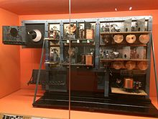](https://en.wikipedia.org/wiki/File:Watson_Radar.jpg)

The first workable unit built by [Robert Watson-Watt](https://en.wikipedia.org/wiki/Robert_Watson-Watt) and his team

In 1935, Watson-Watt was asked to judge recent reports of a German radio-based [death ray](https://en.wikipedia.org/wiki/Death_ray) and turned the request over to Wilkins. Wilkins returned a set of calculations demonstrating the system was basically impossible. When Watson-Watt then asked what such a system might do, Wilkins recalled the earlier report about aircraft causing radio interference. This revelation led to the [Daventry Experiment](https://en.wikipedia.org/wiki/Daventry_Experiment) of 26 February 1935, using a powerful [BBC](https://en.wikipedia.org/wiki/BBC) shortwave transmitter as the source and their GPO receiver setup in a field while a bomber flew around the site. When the plane was clearly detected, [Hugh Dowding](https://en.wikipedia.org/wiki/Hugh_Dowding), the [Air Member for Supply and Research](https://en.wikipedia.org/wiki/Air_Member_for_Supply_and_Research) was very impressed with their system's potential and funds were immediately provided for further operational development.[[25]](https://en.wikipedia.org/wiki/Radar#cite_note-dora-25) Watson-Watt's team patented the device in GB593017.

[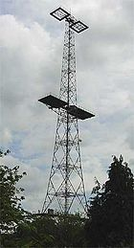](https://en.wikipedia.org/wiki/File:Chain_home.jpg)

A [Chain Home](https://en.wikipedia.org/wiki/Chain_Home) tower in Great Baddow, Essex, United Kingdom

[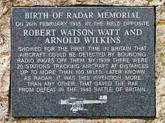](https://en.wikipedia.org/wiki/File:Watson_watt_02_fr.jpg)

Memorial plaque commemorating Robert Watson-Watt and [Arnold Wilkins](https://en.wikipedia.org/wiki/Arnold_Wilkins)

Development of radar greatly expanded on 1 September 1936, when Watson-Watt became superintendent of a new establishment under the British [Air Ministry](https://en.wikipedia.org/wiki/Air_Ministry), Bawdsey Research Station located in [Bawdsey Manor](https://en.wikipedia.org/wiki/Bawdsey_Manor), near Felixstowe, Suffolk. Work there resulted in the design and installation of aircraft detection and tracking stations called "[Chain Home](https://en.wikipedia.org/wiki/Chain_Home)" along the East and South coasts of England in time for the outbreak of World War II in 1939. This system provided the vital advance information that helped the Royal Air Force win the [Battle of Britain](https://en.wikipedia.org/wiki/Battle_of_Britain); without it, significant numbers of fighter aircraft, which Great Britain did not have available, would always have needed to be in the air to respond quickly. If German-aircraft detection had relied solely on the observations of ground-based individuals, Great Britain might have lost the Battle of Britain. The radar formed part of the "[Dowding system](https://en.wikipedia.org/wiki/Dowding_system)" for collecting reports of enemy aircraft and coordinating the response.

Given all required funding and development support, the team produced working radar systems in 1935 and began deployment. By 1936, the first five Chain Home (CH) systems were operational and by 1940 stretched across the entire UK including Northern Ireland. Even by standards of the era, CH was crude; instead of broadcasting and receiving from an aimed antenna, CH broadcast a signal floodlighting the entire area in front of it, and then used one of Watson-Watt's own radio direction finders to determine the direction of the returned echoes. This fact meant CH transmitters had to be much more powerful and have better antennas than competing systems but allowed its rapid introduction using existing technologies.

### **During World War II**

A key development was the [cavity magnetron](https://en.wikipedia.org/wiki/Cavity_magnetron) in the UK, which allowed the creation of relatively small systems with sub-meter resolution. Britain shared the technology with the U.S. during the 1940 [Tizard Mission](https://en.wikipedia.org/wiki/Tizard_Mission).

In April 1940, [*Popular Science*](https://en.wikipedia.org/wiki/Popular_Science) showed an example of a radar unit using the Watson-Watt patent in an article on air defense.[[31]](https://en.wikipedia.org/wiki/Radar#cite_note-31) Also, in late 1941 *Popular Mechanics* had an article in which a U.S. scientist speculated about the British early warning system on the English east coast and came close to what it was and how it worked.[[32]](https://en.wikipedia.org/wiki/Radar#cite_note-Hearst_Magazines_26-32) Watson-Watt was sent to the U.S. in 1941 to advice on air defense after Japan's [attack on Pearl Harbor](https://en.wikipedia.org/wiki/Attack_on_Pearl_Harbor).[[33]](https://en.wikipedia.org/wiki/Radar#cite_note-33) [Alfred Lee Loomis](https://en.wikipedia.org/wiki/Alfred_Lee_Loomis) organized the secret [MIT Radiation Laboratory](https://en.wikipedia.org/wiki/MIT_Radiation_Laboratory) at [Massachusetts Institute of Technology](https://en.wikipedia.org/wiki/Massachusetts_Institute_of_Technology), Cambridge, Massachusetts which developed microwave radar technology in the years 1941–45. Later, in 1943, Page greatly improved radar with the [mono-pulse technique](https://en.wikipedia.org/wiki/Monopulse_radar) that was used for many years in most radar applications.

The war precipitated research to find better resolution, more portability, and more features for radar, including complementary navigation systems like [Oboe](https://en.wikipedia.org/wiki/Oboe_(navigation)) used by the [RAF's Pathfinder](https://en.wikipedia.org/wiki/Pathfinder_(RAF)).

**2.1 Theory of work**

 RADAR is a detection system that uses radio waves to determine the distance (ranging), angle, and radial velocity of objects relative to the site of the radar station/device

**Functions of Radar:**

The normal functions of a radar are to detect the range (distance) of target from the pulse delay, velocity (relative velocity) from Doppler frequency shift and angular direction of the target from the direction of antenna pointing, target size from the return signal’s magnitude, target shape and components can be known from the direction and at last the material composition.

The price i.e., cost and size of the radar enhances as the functions of the radar enhances.

**Types of Radar:**

Let us see the classification of radar based on specific function is of two types, they are as follows:

* Primary Radar
* Secondary Radar

The primary radars are classified into two types and they are:

* Continuous wave radar
* Pulse wave radar

The continuous wave radars are classified into two types and they are as follows:

* Modulated continuous wave radar
* Unmodulated continuous wave radar

The pulse wave radars are classified are classified into two types and they are as follows:

* Moving target radar
* Pulse Doppler radar

Primary radar: The primary radar sends high-frequency signals towards the targets and the pulses that were sent by the radar are reflected by the target. The same primary radar receives the signals and those reflected signals are called as echoes, echoes undergo further operations to get the information or data about the target.

Secondary radar: The secondary target uses an extra component than the primary radar called transponder on the target. The radar at the ground level which is called as interrogator transmits or sends the signals to the target. The transponder of the target receives the signal and decodes the signal and after that, it sends the signals to the interrogator unit and this unit demodulate the received signal. Through this, we get various kind of information like the identity of the airplane, position of the airplane and much more. Now, coming on the further classifications we need to describe the following radars:

Continuous wave radar: This type of radar continuously sends the signals towards the target and reflected signals are also received and further operations are done continuously.

* Unmodulated continuous wave radar: This type of radar transmits the signals of continuous amplitude and frequency that are used to detect an only speed of the target by availing the Doppler Effect but cannot measure the range of the target.
* Modulated continuous wave radar: The unmodulated continuous wave radars have the disadvantage of not detecting the range of a target and this can be measured in modulated continuous wave radar by using the frequency shift method.

Pulse wave radar: This type of radars transmits the high-frequency pulses and high-power pulses towards the target. It waits for the received signal before transmitting a new pulse wave.

* MTI (Moving target radar): This type of radar uses low pulse repetition frequency to shun range uncertainties but these radars can possess Doppler uncertainties.
* Pulse Doppler radar: It uses high pulse repetition frequency to avoid Doppler uncertainties but it can possess many range uncertainties.

**2.2 Other Related Works**

Serious developmental work on radar began in the 1930s, but the basic idea of radar had its origins in the classical experiments on electromagnetic radiation conducted by German physicist Heinrich Hertz during the late 1880s. Hertz set out to verify experimentally the earlier theoretical work of Scottish physicist James Clerk Maxwell. Maxwell had formulated the general equations of the electromagnetic field, determining that both light and radio waves are examples of electromagnetic waves governed by the same fundamental laws but having widely different frequencies. Maxwell’s work led to the conclusion that radio waves can be reflected from metallic objects and refracted by a dielectric medium, just as light waves can. Hertz demonstrated these properties in 1888, using radio waves at a wavelength of 66 cm (which corresponds to a frequency of about 455 MHz).

The potential utility of Hertz’s work as the basis for the detection of targets of practical interest did not go unnoticed at the time. In 1904 a patent for “an obstacle detector and ship navigation device,” based on the principles demonstrated by Hertz, was issued in several countries to Christian Hülsmeyer, a German engineer. Hülsmeyer built his invention and demonstrated it to the German navy but failed to arouse any interest. There was simply no economic, societal, or military need for radar until the early 1930s, when long-range military bombers capable of carrying large payloads were developed. This prompted the major countries of the world to look for a means with which to detect the approach of hostile aircraft.

Most of the countries that developed radar prior to World War II first experimented with other methods of aircraft detection. These included listening for the acoustic noise of aircraft engines and detecting the electrical noise from their ignition. Researchers also experimented with infrared sensors. None of these, however, proved effective.

First military radars

During the 1930s, efforts to use radio echoes for aircraft detection were initiated independently and almost simultaneously in eight countries that were concerned with the prevailing military situation and that already had practical experience with radio technology. The United States, Great Britain, Germany, France, the Soviet Union, Italy, the Netherlands, and Japan all began experimenting with radar within about two years of one another and embarked, with varying degrees of motivation and success, on its development for military purposes. Several of these countries had some form of operational radar equipment in military service at the start of World War II.

The first observation of the radar effect at the U.S. Naval Research Laboratory (NRL) in Washington, D.C., was made in 1922. NRL researchers positioned a radio transmitter on one shore of the Potomac River and a receiver on the other. A ship sailing on the river unexpectedly caused fluctuations in the intensity of the received signals when it passed between the transmitter and receiver. (Today such a configuration would be called biostatic radar.) In spite of the promising results of this experiment, U.S. Navy officials were unwilling to sponsor further work. The principle of radar was “rediscovered” at NRL in 1930 when L.A. Hyland observed that an aircraft flying through the beam of a transmitting antenna caused a fluctuation in the received signal. Although Hyland and his associates at NRL were enthusiastic about the prospect of detecting targets by radio means and were eager to pursue its development in earnest, little interest was shown by higher authorities in the navy. Not until it was learned how to use a single antenna for both transmitting and receiving (now termed monostatic radar) was the value of radar for detecting and tracking aircraft and ships fully recognized. Such a system was demonstrated at sea on the battleship USS New York in early 1939.

The first radars developed by the U.S. Army were the SCR-268 (at a frequency of 205 MHz) for controlling antiaircraft gunfire and the SCR-270 (at a frequency of 100 MHz) for detecting aircraft. Both of these radars were available at the start of World War II, as was the navy’s CXAM shipboard surveillance radar (at a frequency of 200 MHz). It was an SCR-270, one of six available in Hawaii at the time, that detected the approach of Japanese warplanes toward Pearl Harbor, near Honolulu, on December 7, 1941; however, the significance of the radar observations was not appreciated until bombs began to fall.

Britain commenced radar research for aircraft detection in 1935. The British government encouraged engineers to proceed rapidly because it was quite concerned about the growing possibility of war. By September 1938 the first British radar system, the Chain Home, had gone into 24-hour operation, and it remained operational throughout the war. The Chain Home radars allowed Britain to deploy successfully its limited air defenses against the heavy German air attacks conducted during the early part of the war. They operated at about 30 MHz—in what is called the shortwave, or HF, band—which is actually quite a low frequency for radar. It might not have been the optimum solution, but the inventor of British radar, Sir Robert Watson-Watt, believed that something that worked and was available was better than an ideal solution that was only a promise or might arrive too late.

The Soviet Union also started working on radar during the 1930s. At the time of the German attack on their country in June 1941, the Soviets had developed several different types of radars and had in production an aircraft-detection radar that operated at 75 MHz (in the very-high-frequency [VHF] band). Their development and manufacture of radar equipment was disrupted by the German invasion, and the work had to be relocated.

At the beginning of World War II, Germany had progressed farther in the development of radar than any other country. The Germans employed radar on the ground and in the air for defense against Allied bombers. Radar was installed on a German pocket battleship as early as 1936. Radar development was halted by the Germans in late 1940 because they believed the war was almost over. The United States and Britain, however, accelerated their efforts. By the time the Germans realized their mistake, it was too late to catch up.

Except for some German radars that operated at 375 and 560 MHz, all of the successful radar systems developed prior to the start of World War II were in the VHF band, below about 200 MHz the use of VHF posed several problems. First, VHF beam widths are broad. (Narrow beam widths yield greater accuracy, better resolution, and the exclusion of unwanted echoes from the ground or other clutter.) Second, the VHF portion of the electromagnetic spectrum does not permit the wide bandwidths required for the short pulses that allow for greater accuracy in range determination. Third, VHF is subject to atmospheric noise, which limits receiver sensitivity. In spite of these drawbacks, VHF represented the frontier of radio technology in the 1930s, and radar development at this frequency range constituted a genuine pioneering accomplishment. It was well understood by the early developers of radar that operation at even higher frequencies was desirable, particularly since narrow beam widths could be achieved without excessively large antennas.

Advances during World War II

The opening of higher frequencies (those of the microwave region) to radar, with its attendant advantages, came about in late 1939 when the cavity magnetron oscillator was invented by British physicists at the University of Birmingham. In 1940 the British generously disclosed to the United States the concept of the magnetron, which then became the basis for work undertaken by the newly formed Massachusetts Institute of Technology (MIT) Radiation Laboratory at Cambridge. It was the magnetron that made microwave radar a reality in World War II. The successful development of innovative and important microwave radars at the MIT Radiation Laboratory has been attributed to the urgency for meeting new military capabilities as well as to the enlightened and effective management of the laboratory and the recruitment of talented, dedicated scientists. More than 100 different radar systems were developed as a result of the laboratory’s program during the five years of its existence (1940–45).

One of the most notable microwave radars developed by the MIT Radiation Laboratory was the SCR-584, a widely used gunfire-control system. It employed conical scan tracking—in which a single offset (squinted) radar beam is continuously rotated about the radar antenna’s central axis—and, with its four-degree beam width, it had sufficient angular accuracy to place antiaircraft guns on target without the need for searchlights or optics, as was required for older radars with wider beam widths (such as the SCR-268). The SCR-584 operated in the frequency range from 2.7 to 2.9 GHz (known as the S band) and had a parabolic reflector antenna with a diameter of nearly 6.6 feet (2 meters). It was first used in combat early in 1944 on the Anzio beachhead in Italy. Its introduction was timely, since the Germans by that time had learned how to jam its predecessor, the SCR-268. The introduction of the SCR-584 microwave radar caught the Germans unprepared.

Postwar progress

After the war, progress in radar technology slowed considerably. The last half of the 1940s was devoted principally to developments initiated during the war. Two of these were the monopoles tracking radar and the moving-target indication (MTI) radar (discussed in the section Doppler frequency and target velocity). It required many more years of development to bring these two radar techniques to full capability.

New and better radar systems emerged during the 1950s. One of these was a highly accurate monopoles tracking radar designated the AN/FPS-16, which was capable of an angular accuracy of about 0.1 mill radian (roughly 0.006 degree). There also appeared large, high-powered radars designed to operate at 220 MHz (VHF) and 450 MHz (UHF). These systems, equipped with large mechanically rotating antennas (more than 120 feet [37 meters] in horizontal dimension), could reliably detect aircraft at very long ranges. Another notable development was the klystron amplifier, which provided a source of stable high power for very-long-range radars. Synthetic aperture radar first appeared in the early 1950s, but it took almost 30 more years to reach a high state of development, with the introduction of digital processing and other advances. The airborne pulse Doppler radar also was introduced in the late 1950s in the Bomarc air-to-air missile.

The decade of the 1950s also saw the publication of important theoretical concepts that helped put radar design on a more quantitative basis. These included the statistical theory of detection of signals in noise; the so-called matched filter theory, which showed how to configure a radar receiver to maximize detection of weak signals; the Woodward ambiguity diagram, which made clear the trade-offs in waveform design for good range and radial velocity measurement and resolution; and the basic methods for Doppler filtering in MTI radars, which later became important when digital technology allowed the theoretical concepts to become a practical reality.

The Doppler frequency shift and its utility for radar were known before World War II, but it took years of development to achieve the technology necessary for wide-scale adoption. Serious application of the Doppler principle to radar began in the 1950s, and today the principle has become vital in the operation of many radar systems. As previously explained, the Doppler frequency shift of the reflected signal results from the relative motion between the target and the radar. Use of the Doppler frequency is indispensable in continuous wave, MTI, and pulse Doppler radars, which must detect moving targets in the presence of large clutter echoes. The Doppler frequency shift is the basis for police radar guns. SAR and ISAR imaging radars make use of Doppler frequency to generate high-resolution images of terrain and targets. The Doppler frequency shift also has been used in Doppler-navigation radar to measure the velocity of the aircraft carrying the radar system. The extraction of the Doppler shift in weather radars, moreover, allows the identification of severe storms and dangerous wind shear not possible by other techniques.

The first large electronically steered phased-array radars were put into operation in the 1960s. Airborne MTI radar for aircraft detection was developed for the U.S. Navy’s Grumman E-2 airborne-early-warning (AEW) aircraft at this time. Many of the attributes of HF over-the-horizon radar were demonstrated during the 1960s, as were the first radars designed for detecting ballistic missiles and satellites.

Radar in the digital age

During the 1970s digital technology underwent a tremendous advance, which made practical the signal and data processing required for modern radar. Significant advances also were made in airborne pulse Doppler radar, greatly enhancing its ability to detect aircraft in the midst of heavy ground clutter. The U.S. Air Force’s airborne-warning-and-control-system (AWACS) radar and military airborne-intercept radar depend on the pulse Doppler principle. It might be noted too that radar began to be used in spacecraft for remote sensing of the environment during the 1970s.

Over the next decade radar methods evolved to a point where radars were able to distinguish one type of target from another. Serial production of phased-array radars for air defense (the Patriot and Aegis systems), airborne bomber radar (B-1B aircraft), and ballistic missile detection (Pave Paws) also became feasible during the 1980s. Advances in remote sensing made it possible to measure winds blowing over the sea, the geoid (or mean sea level), ocean roughness, ice conditions, and other environmental effects. Solid-state technology and integrated microwave circuitry permitted new radar capabilities that had been only academic curiosities a decade or two earlier. Continued advances in computer technology in the 1990s allowed increased information about the nature of targets and the environment to be obtained from radar echoes. The introduction of Doppler weather radar systems (as, for example, Nexrad), which measure the radial component of wind speed as well as the rate of precipitation, provided new hazardous-weather warning capability. Terminal Doppler weather radars (TDWR) were installed at or near major airports to warn of dangerous wind shear during takeoff and landing. Unattended radar operation with little downtime for repairs was demanded of manufacturers for such applications as air traffic control. HF over-the-horizon radar systems were operated by several countries, primarily for the detection of aircraft at very long ranges (out to 2,000 nautical miles [3,700 km]). Space-based radars continued to gather information about the Earth’s land and sea surfaces on a global basis. Improved imaging radar systems were carried by space probes to obtain higher-resolution three-dimensional images of the surface of Venus, penetrating for the first time its ever-present opaque cloud cover.

The first ballistic missile defense radars were conceived and developed in the mid-1950s and 1960s. Development in the United States stopped, however, with the signing in 1972 of the antiballistic missile (ABM) treaty by the Soviet Union and the United States. The use of tactical ballistic missiles during the Persian Gulf War  (1990–91) brought back the need for radars for defense against such missiles. Russia (and before that, the Soviet Union) continually enhanced its powerful radar-based air-defense systems to engage tactical ballistic missiles. The Israelis deployed the Arrow phased-array radar as part of an ABM system to defend their homeland. The United States developed a mobile active-aperture (all solid-state) phased-array called Theater High Altitude Area Defense Ground Based Radar (THAAD GBR) for use in a theatre wide ABM system.

Advances in digital technology in the first decade of the 21st century sparked further improvement in signal and data processing, with the goal of developing (almost) all-digital phased-array radars. High-power transmitters became available for radar application in the millimeter-wave portion of the spectrum (typically 94 GHz), with average powers 100 to 1,000 times greater than previously.

**2.3 Radar equation:**

The power Pr returning to the receiving antenna is given by the radar equation:

Pr =

Where

• Pt = transmitter power

• Gt = gain of the transmitting antenna

• Ar = effective aperture (area) of the receiving antenna

• σ = radar cross section or scattering coefficient, of the target

• F = pattern propagation factor

• Rt = distance from the transmitter to the target

• Rr = distance from the target to the receiver.

In the common case where the transmitter and the receiver are at the same location, Rt = Rr and the term Rt² Rr² can be replaced by R, where R is the range. These yields:

This shows that the received power declines as the fourth power of the range, which means that the reflected power from distant targets is very, very small. The equation above with F = 1 is a simplification for vacuum without interference. The propagation factor accounts for the effects of multipath and shadowing and depends on the details of the environment. In a real-world situation, path loss effects should also be considered.

**2.3.1Analysis**:

The frequency of the sounds that the source emits does not actually change. To understand what happens, consider the following analogy. Someone throws one ball every second in a man's direction. Assume that balls travel with constant velocity. If the thrower is stationary, the man will receive one ball every second.

However, if the thrower is moving towards the man, he will receive balls more frequently because the balls will be less spaced out. The inverse is true if the thrower is moving away from the man. So it is actually the wavelength which is affected.

As a consequence, the received frequency is also affected. It may also be said that the velocity of the wave remains constant whereas wavelength changes; hence frequency also changes. If the source moving away from the observer is emitting waves through a medium with an actual frequency f0, then an observer stationary relative to the medium detects waves with a frequency f given by

Where VS. Is positive if the source is moving away from the observer, and negative if the source is moving towards the observer. A similar analysis for a moving observer and a stationary source yields the observed frequency (the receiver's velocity being represented as Vr): )

Where the similar convention applies: Vr is positive if the observer is moving towards the source and negative if the observer is moving away from the source. These can be generalized into a single equation with both the source and receiver moving.

With a relatively slow moving source, vs, r is small in comparison to v and the equation approximates to

Where Vs, r = Vs-Vr

However the limitations mentioned above still apply. When the more complicated exact equation is derived without using any approximations (just assuming that source, receiver, and wave or signal are moving linearly relatively to each other) several interesting and perhaps surprising results are found. For example, as Lord Rayleigh noted in his classic book on sound, by properly moving it would be possible to hear a symphony being played backwards. This is the so-called "time reversal effect" of the Doppler Effect. Other interesting conclusions are that the Doppler effect is time-dependent in general (thus we need to know not only the source and receivers' velocities, but also their positions at a given time), and in some circumstances it is possible to receive two signals or waves from a source, or no signal at all. In addition there are more possibilities than just the receiver approaching the signal and the receiver receding from the signal.

The approach to this design is realized through the design and construction (mostly assembly) of its components which as stated earlier are it Transmitter, Antenna, Receiver and some form of display unit. But the icing to the cake would be the software implementation that allows the analog signal/data captured by the RADAR system setup to be digitalize for accessibility and further research. In order to achieve these, programs are going to be written by the design team to aid in manipulating the voltage input (radio echo signal) gotten from the receiver into meaning digital/visual formats which would be used to obtain and extract information about the detected object.

**3.1 Principles Applied in the design**

The principles applied in this paper are based on engineering concept.

These principles are listed below:

* Modulation of Radio wave to enable transmission with relatively small antenna sizes
* Reflection of Electromagnetic waves from an object
* Doppler Effect on Waves when observed from a reference point with relative motion to the wave producer (source)

**3.2 Components and materials**

The components/materials used for the construction of the Radar system are explained below with their uses in the project

**3.2.1 Antenna (Parabolic Antenna)**

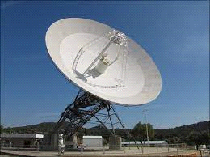

**Fig 3.x: Typical Parabolic Antenna (Dish)**

An Antenna or an Arial is the interface between radio waves propagation through space and electric currents moving in the metals conductors, used with a transmitter or receiver.

A parabolic antenna is an antenna that used a parabolic reflector, a curved surface with cross-sectional shape or a parabola, to direct the radio waves to the receiver in its focal point. The most common form is shaped like a dish and popularly called a dish antenna or parabolic dish

**3.2.2 Transceiver Unit**

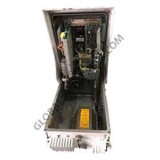

**Fig 3.x: Typical Transceiver**

A Transceiver is a combination of transmitter and receiver in a single package used to convert electronic signals into EM signals and vice versa

* **Transmitter**

A Transmitter is an electronic device that produces radio wave with an antenna. The Transmitter itself generates a radio frequency alternating current, which is applied to the antenna. When excited by the alternating current, the antenna radiates radio waves.

* **Receiver**

A receiver is a device that accepts signals, such as radio waves, converts and amplifies it into a useful form. It is used with antenna. The antenna intercepts radio waves (electromagnetic waves of radio frequency) and converts them to tiny alternating currents which are applied to the receiver, and the receiver extracts the desired information. The receiver uses electronic filters to separate the desired radio frequency signal from all the other signals picked up by the antenna electronic amplifier to increase the power of the signal for further processing and finally recovers the desired information through demodulation

**3.2.3 Duplexer**

A Duplexer is an electronic device that allows bi-directional communication over a single path. In Radar and Radio Communication systems it isolates the receiver from the transmitter while permitting them to share a common antenna.

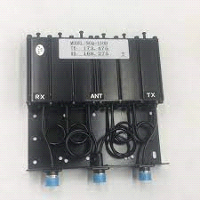

**Fig 3.x: Radar Duplexer**

Most radio repeater systems include a duplexer. Duplexer can be based on frequency (often a waveguide filter), polarization (such as an orthomode transducer), or timing (as is typical in radar).

**3.2.4 Processing Unit**

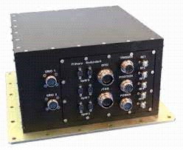

**Fig 3.x: Radar processing unit**

The Radar controller and processing unit (RCPU) is a radar sub-system providing resources for Radar Signal Processing, Radar Data Processing and Radar Data Recording. The RCPU consists of the following lines-replaceable units (LRUs)

* Signal Processor
* Data Processor and Controller Unit (DPCU)
* Radar Data Recorder Unit (RDRU)
* Power Distribution and Control Unit (PDCU)

**3.2.5 Radar Display Unit/System**

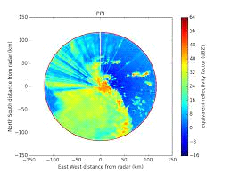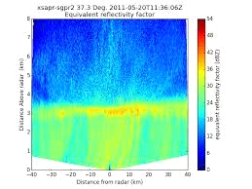

**Fig 3.x: Example of Radar Display (visual output)**

A Radar display is usually an electronic device to present radar data to the operator. The radar system transmits pulses of continuous waves of electromagnetic radiation, a small portion of which backscatter off targets (intended or otherwise) and return to the radar system. After the receiver converts all received all received electromagnetic radiation into a continuous electronic analog signal of varying (or oscillating) voltage that can be converted then to a screen display. In our case we intend the achieve this conversion by a using a computer program that intercepts the analog electronic signal and produces a data structure which can be manipulated to produce meaningful and accurate radar readings digitally.

**3.3 Material Selection:** The selection of materials for the fabrication seems like a very complicated process for engineers. In making good selection of material there are some factor to be consider which are:

* Material properties: The expected level of performance form the material
* Material cost and availability: material must be priced appropriately and the material must be readily available or abundant in nature to use.
* Processing: must consider how to make the part either casting, machining , welding or assembly
* Environmental reaction: Reaction between material and its environment must be favorable and the material must be able to withstand the environment conditions without much deformation.

**3.4 Principle of Operation**

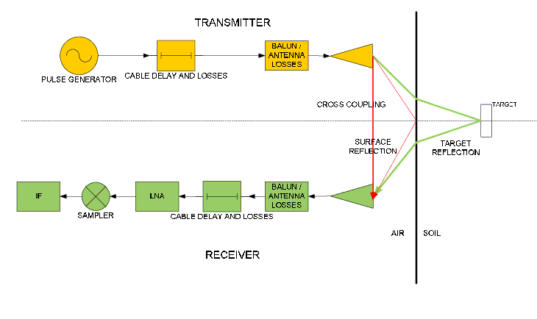

**Fig. 3.x: Schematic Diagram of a Radar System**

The designed system consist primary of a Transmitter and a Receiver Subsystem, the transmitter subsystem is responsible for generating and then transmitting the specified radio signal into the direction that is be observed. When the radio waves comes in contact with an object, some part of it is absorbed by the object and some other portion of it is reflected (scattered), therefore some move back to the antenna and Duplexer system is used to isolate the path of the incoming signal to move to the receiver subsystem, upon reception by the receiver subsystem the echo radio signal is processed and finally passed on to some storage system or display unit for further analysis or to obtain the necessary information about the object it was reflected from , those information include, Range (distance of the object from the Radar’s Antenna)and its relative velocity with the radar system. Other information like size, conductivity and density can also be obtained from the reflected radio waves.

A radar system has a transmitter that emits radio waves called a radar signals in predetermined directions. When these come into contact with an object they are usually reflected or scattered in many directions Example: - let us take example for bat

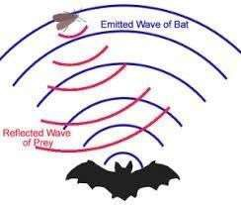Bat released the eco sound while travelling .if any object came in middle and it reflect back to the bat

**Applications and usages:-**

The development of the radar technology took place during the World War II in which it was used for detecting the approaching aircraft and then later for many other purposes which finally led to the development of advanced military radars being used these days. Military radars have a highly specialized design to be highly mobile and easily transportable, by air as well as ground. Military radar should be an early warning, altering along with weapon control functions. It is specially designed to be highly mobile and should be such that it can be deployed within minutes.

### Here’s a summary of how a radar works

* Magnetron generates high-frequency radio waves.
* Duplexer switches magnetron through to antenna.
* Antenna acts as transmitter, sending narrow beam of radio waves through the air.

Radio waves hit enemy airplane and reflect back.

**Advancement to Radar Technology in the recent years**

Modern radar systems often have imaging capability, can yield digitized signals quickly and easily for use with graphical overlays, can be networked together so the total system is greater than the sum of its parts, and can serve several different functions—such as wide-area search, target tracking, fire control, and weather monitoring—where previous generations of radar technology required separate systems to do the same jobs.

Most important, however, is the relative ease and speed with which modern analog radar signals can be converted to digital information. Not only does this open a wide variety of signal processing options, but it also enables radar information to be made available in real time or near real time on Internet-type networks for inclusion in the digital battlefield and Global Information Grid visions of the future.

**RF Energy**

Radar works essentially by bouncing radio waves off a target and detecting the return signals. “Radar systems as early as World War II were simple, but were state-of-the-art for that time,” says Mark Russell, vice president of engineering for integrated defense systems at Raytheon Co. in Tewksbury, Mass. Those early radar systems were tube based and mechanically steered, and involved RF transmitters, RF receivers, analog signal processing, and a video display.

Later, radar systems improved in sensitivity to where they could virtually detect and monitor waves on the ocean and insects in the air. Increasing sensitivity, however, compounded one of the biggest challenges that radar systems confront—so-called clutter, or reflected signals from objects that are not of interest. In World War II when radar technology was not nearly as sensitive as it is today, this was not a big problem. Large objects showed up as blips, while relatively small things of no interest didn’t show up at all.

Increasingly sensitive radar systems were able to detect wave action on the ocean’s surface, but they could have difficulty trying to find an enemy periscope in a rough ocean. Radar designers originally dealt with the clutter problem by finely tuning transmitted RF signals to match the return signals of targets of interest as closely as possible. Engineers tune transmit signals by altering the size of transmit antenna modules. Finely tuning transmit signals for targets of interest has helped reject clutter, but can make radar systems useful only for a narrow range of applications. Hence, users needed a separate radar system for wide-area surveillance, target tracking, fire control, and weather monitoring.

Therefore in recent years, radar system with increasing and varying level of RF energies has been developed, which when compared to the early operation radar systems are much more highly superior in sensitivity and ranges.

**Detecting vital signs**

The need for in-cabin sensing systems to detect children effectively is being driven by governments, local regulations, and consumer demand. Automakers are eager to respond by implementing solutions that can be cost-effectively integrated into any vehicle they manufacture.

Not only do radar sensors meet today’s requirements, they have already evolved to address emerging concerns for child detection.

For example, the 60-GHz single-chip AWR6843 mmWave sensor from Texas Instruments (TI) has fine movement-detection capabilities that can detect breathing, enabling the distinction between a small child and an inanimate object.

More advanced capabilities for TI’s mmWave sensors include simultaneously estimating the heart and breathing rates of both the driver and passengers while the car is moving. The sensor’s range, from its integration into the overhead console or the roof headliner, extends this capability to all passengers. This can enable applications to estimate the fatigue or sleepy state of the driver and activate an alert.

For applications that require higher resolution, such as detecting the posture of a passenger or driver, imaging radar equipped with the mmWave sensors provides high-resolution occupant detection.

**Digital Radar Signals**

Solid-state technology led to digital signal processing, ultrafast analog-to-digital (A-D) and digital-to-analog (D-A) converters, fast commercial off-the-shelf (COTS) microprocessors, and high-speed digital networking. Increasingly, radar systems handle all signal processing in the digital realm, rather than in analog, which offers increasingly fast and efficient processing, broad new opportunities for offering radar information on the tactical Internet, as well as innovative new ways to display radar information.

In essence, once radar signals are converted from analog to digital, they are limited only by the state of the art in digital processing, which today is not a serious limitation at all. “It’s not a processing problem,” Russell says, explaining that new powerful generations of field-programmable gate arrays are available to process complex fast Fourier transform (FFT) algorithms on which radar processing depends.

In fact today’s latest generations of FPGAs, digital signal processors (DSPs), powerful COTS microprocessors, and multiprocessing computing architectures are enabling radar systems designers to put radar-processing algorithms written decades ago into use. With such digital computing power at their command, radar systems designers can even start thinking about doing without processes like digital down-conversion, and can begin designing systems able to sample signals immediately after they are digitized.

**Transmit/Receive Efficiency**

Improvement in radar systems, however, is not happening only on the digital side. New semiconductor materials, such as gallium arsenide (GaAs) and gallium nitride (GaN) are helping systems designers improve efficiency and shrink overall system size.

**Imagine Radar**

The enhanced transmit/receive and computer-processing technologies of modern radar systems also are giving rise to imaging radar systems—or those that produce high-resolution pictures from returning signals.

Although imaging radar is not a new technology, until recently it involved recording volumes of radar data in the air and performing intensive processing later on the ground. Today the imaging radars are doing image formation in real time. Processing time is less than aperture time, so it is nearly real-time image generation, or radar acting like a camera.

**Multiple Functional Radar**

Perhaps the most important development in radar technology in recent years is the shift to multifunction radar—or systems that can perform a variety of applications with the same system. The move to solid-state radar gave the first glimpse of performing several applications with the same radar.

The kinds of active electronically steered radar arrays that solid-state technology enabled is where you get into the transmit/receive module, and that is how we get away from the single-purpose radar. Multifunction radar systems can save on space, weight, and power by combining several stand-alone radars into one system, and also can help reduce demands for human operators by combining functions and systems.

**Sustainability and Growth**

Radar designers are not only seeking to improve system capability, however. In these budget-constrained days they also are looking into radar architectures designed for growth, technology insertion, and long-term sustainability.

**CHAPTER THREE**

MEDTHODOLOGY

SYSTEM BLOCK DIAGRAM OF ARDUINO RADAR

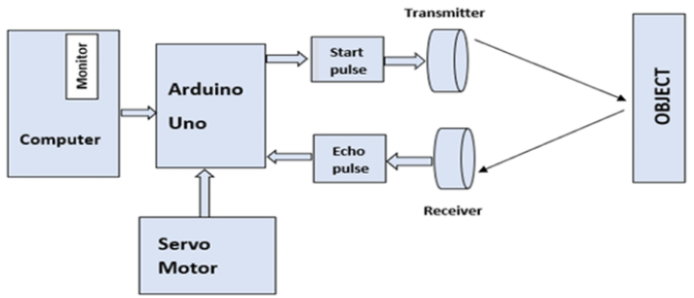

FIGURE 3.1: SYSTEM BLOCK DIAGRAM OF ARDUINO RADAR

**Components Required:**

In this project we have used the Arduino and ultrasonic sensor along with the jumping wires and the relay motors and details list of the hard ware components are

**Arduino IDE (Computer Software):**

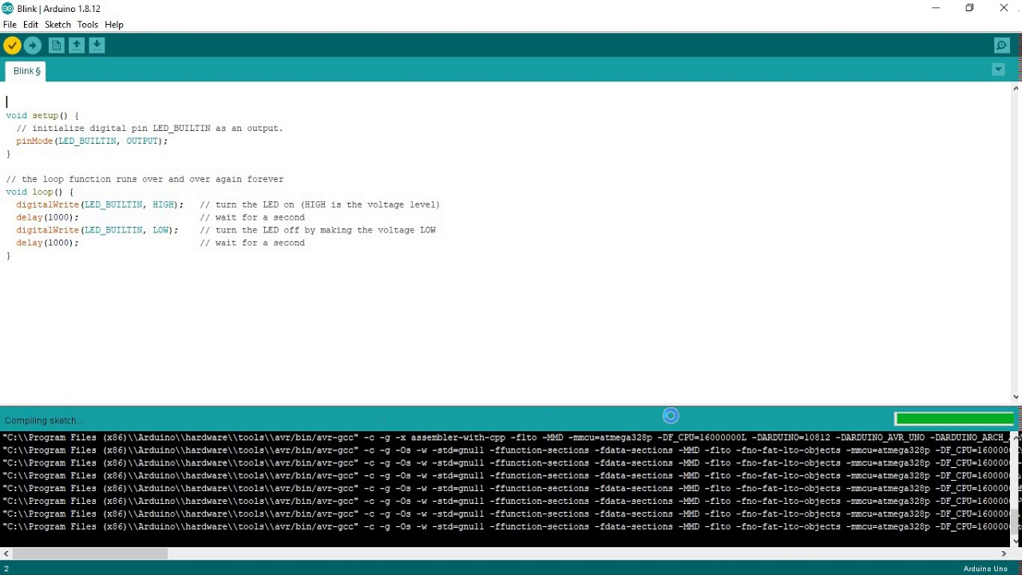

Figure 3.2 Arduino IDE work screen

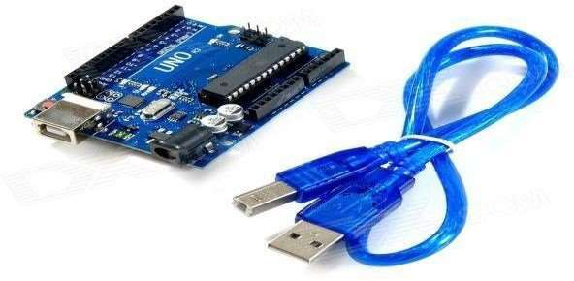**Arduino board and Arduino cable:**

Figure 3.2 Arduino board and cable

**Jumper wires:**

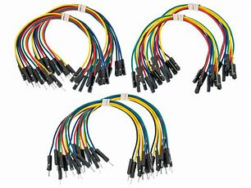

Figure 3.3 Jumper wire

**Breadboard:**

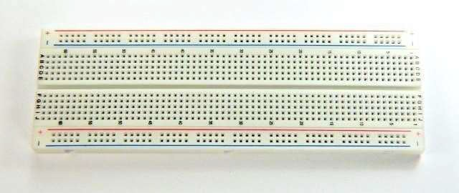

**Figure 3.4 Bread board**

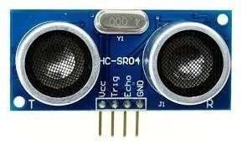**Ultrasonic sensor:**

**Figure 3.5 Ultrasonic sensor**

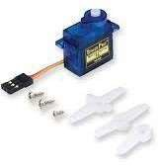 **Servo motor:**

Figure 3.5 Servo motor

**Resistors:**

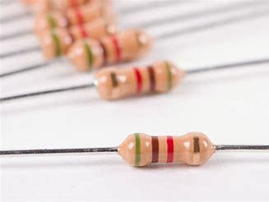

Figure 3.6 Resistors

WORKING PRACTICAL IMPLEMENTATION

**Setting up the Arduino Board/Arduino IDE:**

In order to build a functional prototype of a minimalistic radar system, we used an Arduino Uno R3 board as our base component (microprocessor) and an Arduino computer software to program the board with, which in our case is the Arduino IDE.

Providing the power supply, usually 5 volts. Arduino is ready to use.

After you have done all this, then only the minimum circuitry like crystal oscillator, capacitors, connectors, power supply is required to complete the board. The same circuit can be made on the PCB, either designed or general purpose. Since, Arduino is an Open-Source. Hence, it is easy to make and can have any enhancements as per the requirements

**Connecting Servo Motor**

A servomotor is a rotary actuator that allows for precise control of angular position, velocity and acceleration.

A normal servo motor has three terminals:

VCC

GND

PULSE

A servo motor works at normally 4.8 to 6 volts. Ground is provided by connecting it to the Ground of the Arduino. The total time for a servo motor pulse is usually 20ms. To move it to one end of say 0 degree angle, a 1ms pulse is used and to move it to other end i.e. 180 degrees, a 2ms pulse is applied. Hence, according to this to move the axis of the servo motor to the center, a pulse of time 1.5 MS should be applied. For this, the pulse wire of the servo motor is connected to the Arduino that provides the digital pulses for pulse width modulation of the pulse. Hence, by programming for a particular pulse interval the servo motor can be controlled easily

**Connecting Ultrasonic Sensor:-**

An Ultrasonic Sensor consists of three wires. One for Vcc, second for Ground and the third for pulse signal. The ultrasonic sensor is mounted on the servo motor and both of them further connected to the Arduino board. The ultrasonic sensor uses the reflection principle for its working. When connected to the Arduino, the Arduino provides the pulse signal to the ultrasonic sensor which then sends the ultrasonic wave in forward direction. Hence, whenever there is any obstacle detected or present in front, it reflects the waves which are received by the ultrasonic sensor.

If detected, the signal is sent to the Arduino and hence to the PC/laptop to the processing software that shows the presence of the obstacle on the rotating RADAR screen with distance and the angle at which it has been detected.5



##### USING PROCESSING SOFTWARE

**VII.**

Processing is an open source programming language and integrated development environment (IDE) built for the electronic arts, new media art, and visual design communities with the purpose of teaching the fundamentals of computer programming in a visual context, and to serve as the foundation for electronic sketchbooks. The project was initiated in 2001 by Casey Reas and Benjamin Fry, both formerly of the Aesthetics and Computation Group at the MIT Media Lab. One of the stated aims of Processing is to act as a tool to get non-programmers started with programming, through the instant gratification of visual feedback. The language builds on the Java language, but uses a simplified syntax and graphics programming models.

SOFTWARE UESED IN THIS PROJECT

ARDUINO SOFTWARE

PROCESSING SOFTWARE:-

**CHAPTER FOUR**

**CONSTRUCTON AND TESTING**

**TESTING OF INDIVODUAL COMPONENTS:**

The following were the types of testing taken of their individual component

UNIT TESTING:

In this menu items were tested to ensure on functions has been missed out. This is done for smooth working of the project:

Firstly both the relay motor and Ultrasonic sensor where tested to ensure both had no faulty and are in a proper condition, before being connected to the Arduino board were put under test to see if it can move round and detect objects around it.

SYSTEM TESTING AND RESULTS

After the unit testing we have to perform integration testing. The goal is to see if module can be integrated properly, the emphasis being on testing interface between modules. After the modules are connected we have to perform the total testing.

System testing is the process of executing software in a controlled manner, in order to answer the questions “Does the system behave as specified?” System testing is often used with the terms verification and validation. Verification is the checking of items, including software for conformance and constituency with an associated specification.

LOGICAL TESTING:

This will be used to test every aspect of both modes, report and query as soon as it is implemented, using valid, invalid and extreme data test data will be added to test each code module and result compared with the expected result. Sufficient data will be added to ensure that there is at least one entry in each category.

FUNCFTIONAL TESTING:

In this menu item s were tested to ensure no functions has been missed out. This is done for smooth working of the project.

SYSTEM TESTING:

This is done after the completion of the system all the queries carried out again to ensure that no error have been introduced

BELOW are the result of some of the test taken;

Complete code for the Controlling the Arduino Microprocessor:

(Comments are included within the code to aid readability, comments starts with //)

#include <Servo.h>

#define echoPin 2

#define trigPin 3

// create a variable to hold the duration and distance data

unsigned long duration;

int distance;

int start_angle=0;

int end_angle=180;

//create an object for controlling the Servomotor

Servo myServo;

void setup() {

// put your setup code here, to run once:

pinMode(trigPin, OUTPUT);

pinMode(echoPin, INPUT);

Serial.begin(9600);

myServo.attach(12);

Serial.println("UltraSonic Sensor Test");

Serial.println("With Arduino Uno R3");

}

void loop() {

// put your main code here, to run repeatedly:

for(int i=start_angle;i<end_angle;i++){

myServo.write(i);

delay(30);

distance = calculateDistance();

Serial.print(i);

Serial.print(",");

Serial.print(distance);

Serial.print(".");

}

for(int i=end_angle; i>start_angle;i--){

myServo.write(i);

delay(30);

distance = calculateDistance();

Serial.print(i);

Serial.print(",");

Serial.print(distance);

Serial.print(".");

}

}

int calculateDistance(){

digitalWrite(trigPin, LOW);

delayMicroseconds(2);

digitalWrite(trigPin, HIGH);

delayMicroseconds(10);

digitalWrite(trigPin, LOW);

while ((duration = pulseIn(echoPin, HIGH)) == 0){

Serial.println("Waiting for update...");

};

distance = duration * 0.034 / 2;

return distance;

}

In order to display the data received from the Ultra-sonic sensor, we need another application that can be linked to the Arduino microprocessor through serial communication across the host computer running the Arduino. The Application used for this purpose is the *Processing* application (https:www.processing.org), which starts a serial connection to the defined Arduino ports and generate the radar display upon which echo signal will be display, it then waits until data starts to stream down the serial port from the Servo-motor and the Ultra-Sonic Senor.

Complete Code for the Processing application,

(Comments are included in the code to improve readability, comment starts with //)

import processing.serial.*;

import java.awt.event.KeyEvent;

import java.io.IOException;

Serial myPort;

String angle="";

String distance="";

String data="";

String noObject="";

float pixsDistance;

int iAngle, iDistance;

int index1=0;

int index2=0;

void setup(){

size(1300, 700);

smooth();

myPort = new Serial(this, "COM7", 9600);

myPort.bufferUntil('.'); // reads the data from the serial // port up to the character '.'. So actually it reads this: // angle, distance.

}

void draw() {

fill(98,245,31);

noStroke();

fill(0,4);

rect(0, 0, width, height-height*0.065);

fill(98,245,31); // green color

drawRadar();

drawLine();

drawObject();

drawText();

print("program has started successfully");

}

void serialEvent(Serial p) {

// starts reading data from the Serial Port

// reads the data from the Serial Port up to the

// character '.' and puts it into the String variable

// "data".

data = p.readStringUntil('.');

data = data.substring(0,data.length()-1);

index1 = data.indexOf(","); // find the character ','

// and puts it into the variable "index1"

angle = data.substring(0, index1); // read the data from // position "0" to position of the variable index1 or

// thats the value of the angle the Arduino Board sent

// into the Serial Port

distance = data.substring(index1+1, data.length());

// read the data from position "index1" to the end of the // data pr thats the value of the distance

// converts the String variables into Integer

iAngle = int(angle);

iDistance = int(distance);

print("Int Angle = ");

print(iAngle);

}

void drawRadar() {

pushMatrix();

translate(width/2,height-height*0.074); // moves the

// starting coordinate to new location

noFill();

strokeWeight(2);

stroke(98,245,31);

// draws the arc lines

arc(0,0,(width-width*0.0625),(width-width*0.0625),PI,TWO_PI);

arc(0,0,(width-width*0.27), (width-width*0.27), PI,TWO_PI);

arc(0,0,(width-width*0.479), (width-width*0.479), PI,TWO_PI);

arc(0,0,(width-width*0.687), (width-width*0.687), PI,TWO_PI);

// draws the angle lines

line(-width/2,0,width/2,0);

line(0,0,(-width/2)*cos(radians(30)),(-width/2)*sin(radians(30)));

line(0,0,(-width/2)*cos(radians(60)),(-width/2)*sin(radians(60)));

line(0,0,(-width/2)*cos(radians(90)),(-width/2)*sin(radians(90)));

line(0,0,(-width/2)*cos(radians(120)),(-width/2)*sin(radians(120)));

line(0,0,(-width/2)*cos(radians(150)),(-width/2)*sin(radians(150)));

line((-width/2)*cos(radians(30)),0,width/2,0);

popMatrix();

}

void drawObject() {

pushMatrix();

translate(width/2,height-height*0.074); // moves the

//starting coordinate to new location

strokeWeight(9);

stroke(255, 10, 10); // red color

pixsDistance = iDistance*((height-height*0.1666)*0.025); // covers the distance from the sensor from cm to pixels

// limiting the range to 40 cms

if(iDistance<40){

// draws the object according to the angle and the distance

line(pixsDistance*cos(radians(iAngle)),-pixsDistance*sin(radians(iAngle)),(width-width*0.505)*cos(radians(iAngle)),-(width-width*0.505)*sin(radians(iAngle)));

}

popMatrix();

}

void drawLine() {

pushMatrix();

strokeWeight(9);

stroke(30,250,60);

translate(width/2,height-height*0.074);

// moves the starting coordinats to new location

line(0,0,(height-height*0.12)*cos(radians(iAngle)),-(height-height*0.12)*sin(radians(iAngle))); // draws the line according to the angle

popMatrix();

}

void drawText() {

// draws the texts on the screen

pushMatrix();

if(iDistance>40) {

noObject = "Out of Range";

}

else {

noObject = "In Range";

}

fill(0,0,0);

noStroke();

rect(0, height-height*0.0648, width, height);

fill(98,245,31);

textSize(25);

text("10cm",width-width*0.3854,height-height*0.0833);

text("20cm",width-width*0.281,height-height*0.0833);

text("30cm",width-width*0.177,height-height*0.0833);

text("40cm",width-width*0.0729,height-height*0.0833);

textSize(40);

text("Object: ", width-width*0.95, height-height*0.026);

text("Angle: " + iAngle +" °", width-width*0.54, height-height*0.026);

text("Distance: ", width-width*0.26, height-height*0.026);

if(iDistance<40) {

text(" " + iDistance +" cm", width-width*0.225, height-height*0.026);

}

else {

text(" " + "~" +" cm", width-width*0.225, height-height*0.026);

}

textSize(25);

fill(98,245,60);

translate((width-width*0.4994)+width/2*cos(radians(30)),(height-height*0.0907)-width/2*sin(radians(30)));

rotate(-radians(-60));

text("30°",0,0);

resetMatrix();

translate((width-width*0.503)+width/2*cos(radians(60)),(height-height*0.0888)-width/2*sin(radians(60)));

rotate(-radians(-30));

text("60°",0,0);

resetMatrix();

translate((width-width*0.507)+width/2*cos(radians(90)),(height-height*0.0833)-width/2*sin(radians(90)));

rotate(radians(0));

text("90°",0,0);

resetMatrix();

translate(width-width*0.513+width/2*cos(radians(120)),(height-height*0.07129)-width/2*sin(radians(120)));

rotate(radians(-30));

text("120°",0,0);

resetMatrix();

translate((width-width*0.5104)+width/2*cos(radians(150)),(height-height*0.0574)-width/2*sin(radians(150)));

rotate(radians(-60));

text("150°",0,0);

popMatrix();

}